AWS S3 Pratical

Q1 AWS S3 Lifecycle

1. Create public bucket and add object in that bucket and make it public

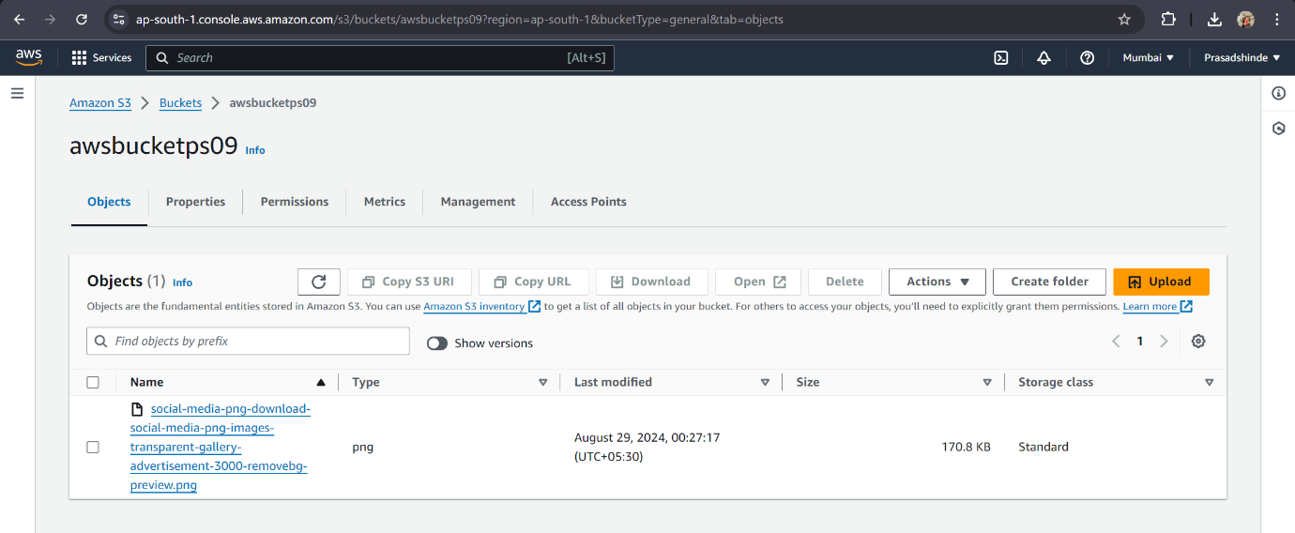

2.Creating rule and apply S3 lifecycle policy to bucket

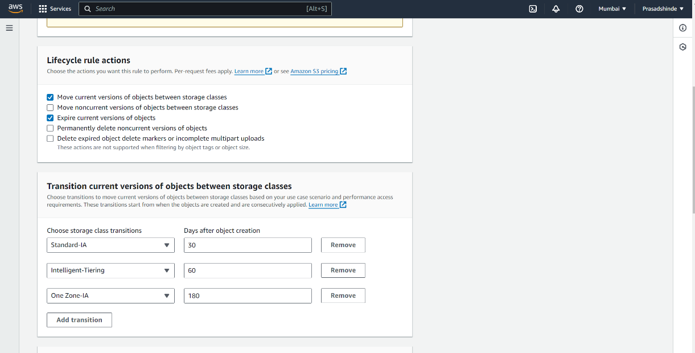

3.S3 lifeCycle configuration

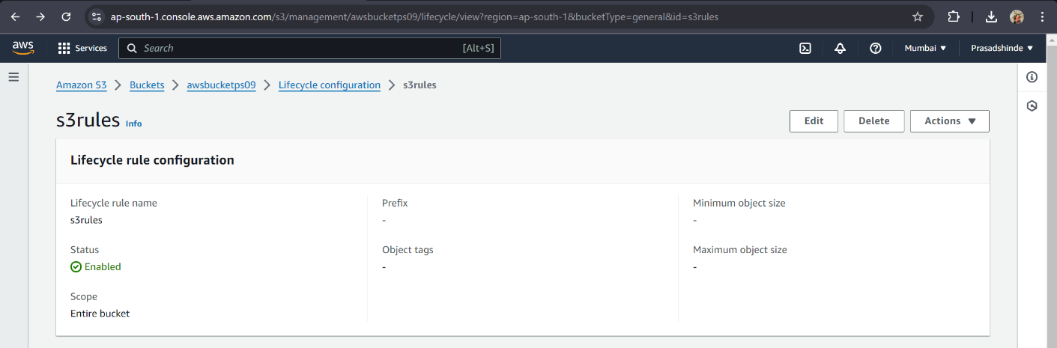

Q2 S3 Versioning

1.Enable S3versioning of bucket

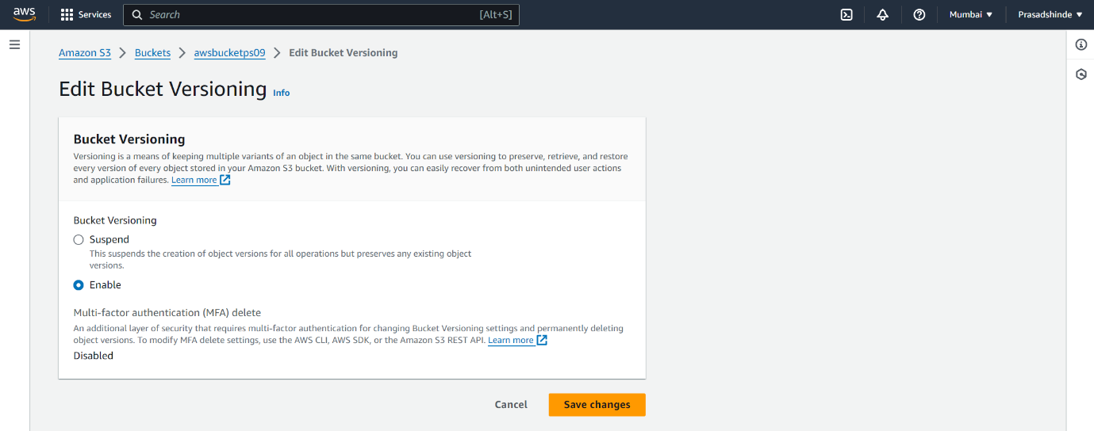

2.After uploading files below are the version created

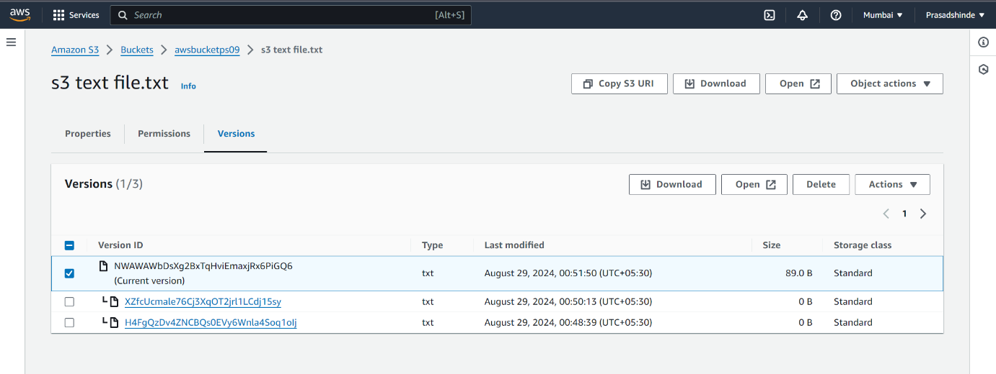

3.Below is the lastest file output

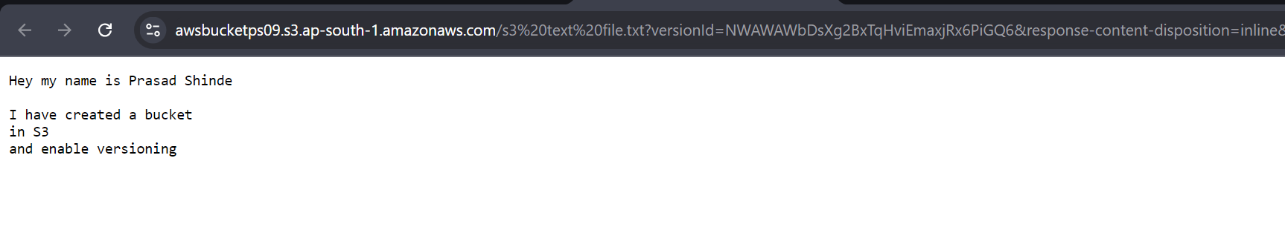

Q3 Cross region Replication

1.Create one more bucket in other region

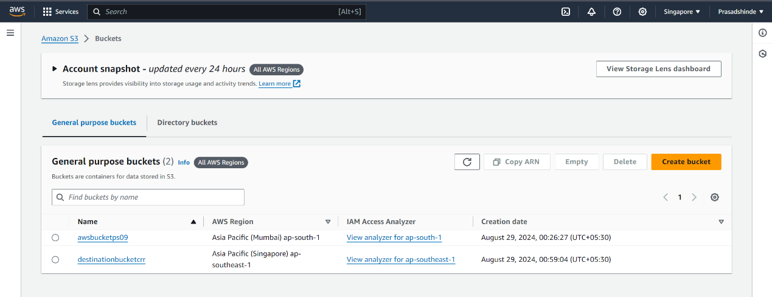

2.Create Replication rule

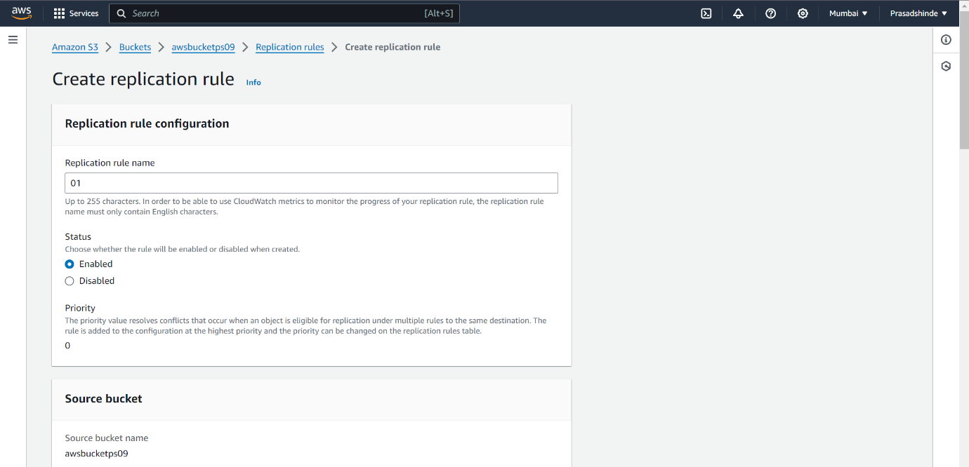

3.Specify Destination Bucket

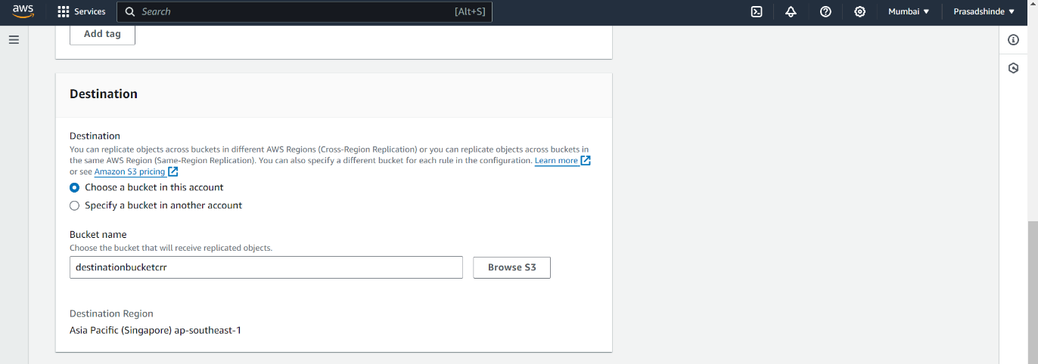

4.upload another file in source bucket

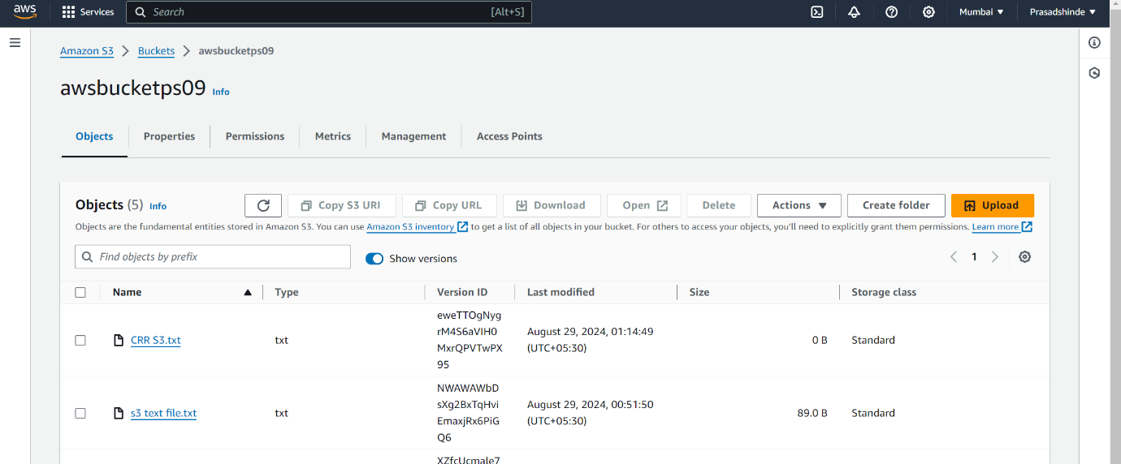

5.Replication rule is applied to destination bucket

